Superstore Sales Data Analysis | Power BI Dashboard
Project Overview

This project analyzes the Superstore Sales dataset to uncover business insights related to sales, profit, customers, products, regions, and categories using Microsoft Power BI.
The dashboard helps stakeholders monitor business performance, identify profitable segments, analyze sales trends, and support data-driven decision-making.

Dataset
Dataset Source: Kaggle
Dataset Name: Superstore Sales Dataset
Format: Excel (.xlsx)

Tools Used
Microsoft Power BI
Power Query
DAX (Data Analysis Expressions)
Microsoft Excel

Dashboard Preview
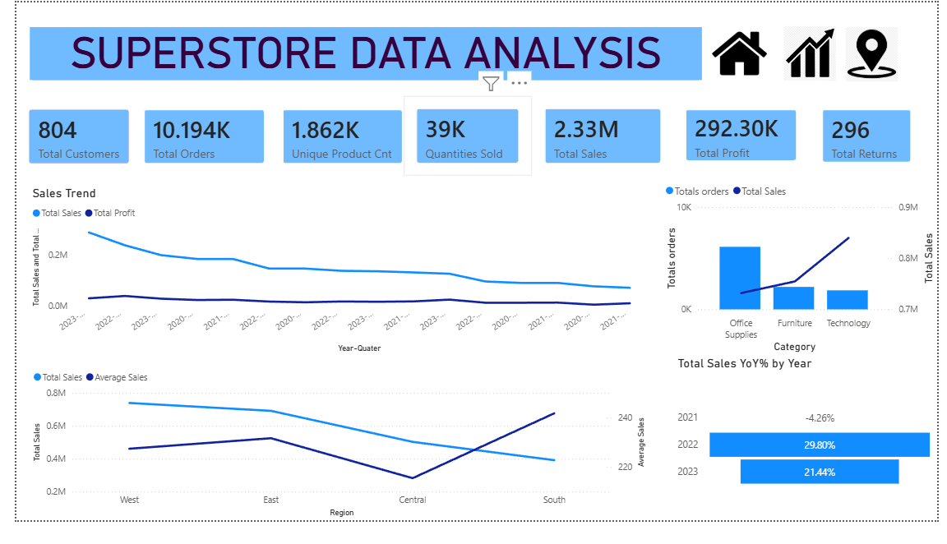
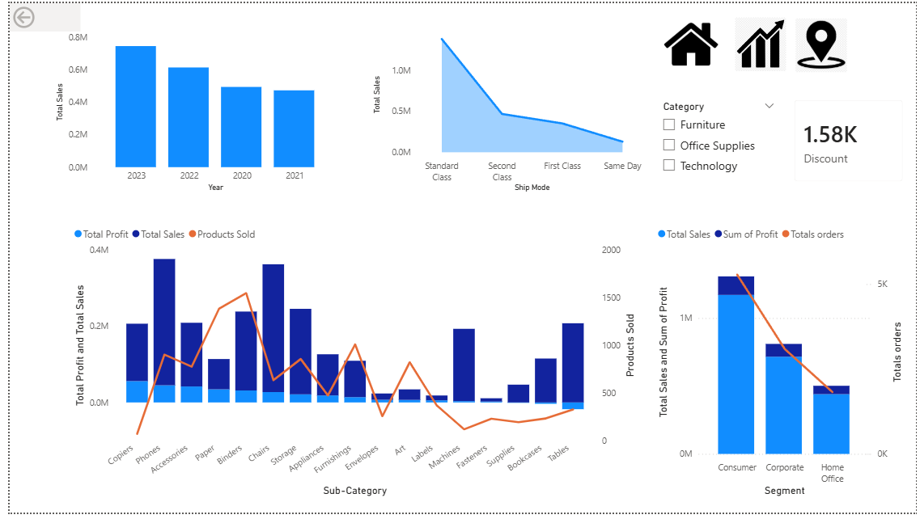
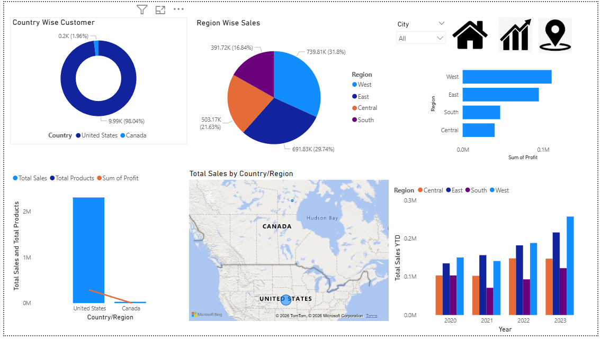

Files Included
- Superstore Sales Data Analysis.pbix
- Superstore Dataset.xlsx
- README.md
- Dashboard Screenshots
- Superstore Dataset Analysis Report

Skills Demonstrated
- Data Cleaning
- Data Transformation
- Data Modeling
- Power Query
- DAX Measures
- KPI Development
- Dashboard Design
- Data Visualization
- Business Insight Generation

